Angular Building Blocks

Module

* Angular Apps are modular in nature
* Angular App is a collection of many individual modules
* Modules are lines of code that can be **imported** or **exported**
* Angular app has at least one module, a root module: AppModule

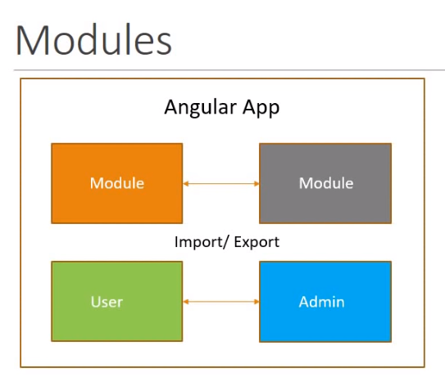

Component

* Controls a portion of the view on the browser
* Angular app has at least one component, the root component: AppComponent
* All the other components are nested inside the root component
* Each component has:
  + HTML Template — Represents the view in the browser
  + 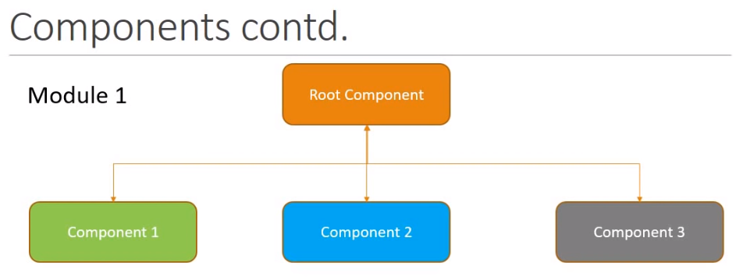Class — Controls the logic of the view

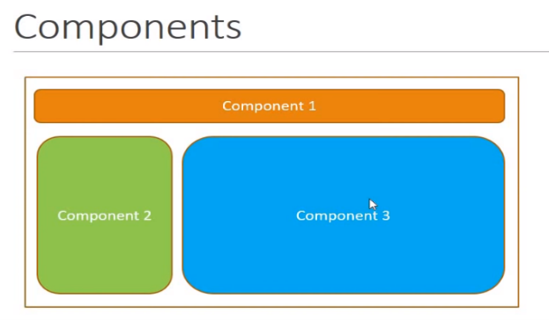

Services

* Contains the business logic of the app
* 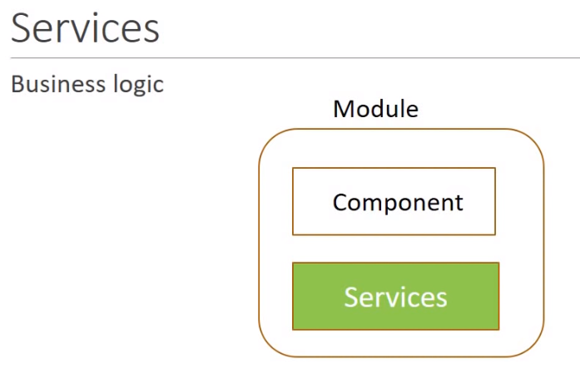

Architecture Summary

* Angular App – contains one or more modules
* Module — One or more components and services
* Components — HTML + class
* Services — Business logic
* Modules interact and ultimately render the view in the browser

Important files

* Package.json
  + Contains a list of the dependencies of the app
    - Libraries or modules which are required for your app to work
  + Scripts which can be executed
* Main.ts
  + An entry point to the app
* App.module.ts
  + Root module of the app
* App.component.ts
  + Root component of the app